AI Science Tutor

Overview
This implementation demonstrates streaming and non-streaming examples of OpenAIAssistantsClient with agent-framework where we are building an AI Science Tutor which explains complex science topics to students using analogies and examples.

Sequential orchestration workflow
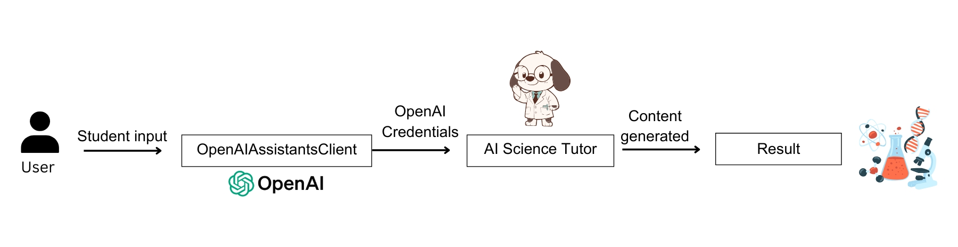
Key Features
- OpenAIAssistantsClient
- OpenAI Credentials
Prerequisites
Before starting, make sure you have:
- OpenAI Credentials in env.
  - OPENAI_CHAT_MODEL_ID="gpt-4o"
  - OPENAI_API_KEY="Your API Key"

- Agent-framework installed.
  - pip install agent-framework

